IX Lecture: Causative agents of gastro-intestinal diseases (genera Escherichia, Shigella, Salmonella, Vibrio, Campylobacter, Helicobacter). Pathogenic anaerobes (genus Clostridium and Bacteroides).

The purpose of the lecture. Morpho-biological properties of bacteria causing pathogens of gastrointestinal infections (Escherichia, Shigella, Salmonella, Vibrio, Campilobacter, Helicobacter species) , microbiological diagnosis, specific principles of treatment and prevention.
Lecture plan:
1. Bacteria that cause gastrointestinal infections.
- Classification of pathogenic bacteria belonging to the genus Escherichia, morpho-biological characteristics, microbiological diagnosis, specific principles of treatment and prevention.
- Classification of pathogenic bacteria belonging to the genus Shigella, morpho-biological characteristics, pathogenic factors, , microbiological diagnosis, specific treatment and prevention principles.
- Classification of pathogenic bacteria belonging to the genus Salmonella, morpho-biological characteristics, , microbiological diagnosis, specific principles of treatment and prevention
2. Vibrios. Classification. Cholera vibrio, morpho-biological characteristics. , microbiological diagnosis, specific principles of treatment and prevention
3. Campylobacter, Helicobacter, their morpho-biological properties. Microbiological diagnosis of diseases,specific principles of treatment and prevention.
4.Anaerobic microorganisms. morfobiological properties of spicies,which caused gaz gangrene ,deaseases ,specific treatment and prevention.
Morfo-biological properties of spicies ,which causes Tetanus,microbiology diagnosis,specific treatment and prevention.
Morfo-biological properties of spicies,which caused botylism,microbiology diagnosis,specific prevention and treatment.
Characteristic and role of Clostridium difficile in pathogenesis process.

ESCHERICHIA
Diseases
Escherichia coli is the most common cause of urinary tract infection and gram-negative rod sepsis. It is one of the two important causes of neonatal meningitis and the agent most frequently associated with “traveler’s diarrhea,” a watery diarrhea. Some strains of E. coli are enterohemorrhagic and cause bloody diarrhea.
Important Properties
Escherichia coli is a straight gram-negative rod , in contrast to the curved gram-negative rods of the genera Vibrio, Campylobacter, and Helicobacter. Escherichia coli is the most abundant facultative anaerobe in the colon and feces. It is, however, greatly outnumbered by the obligate anaerobes such as Bacteroides. Escherichia coli ferments lactose, a property that distinguishes it from the two major intestinal pathogens, Shigella and Salmonella. It has three antigens that are used to identify the organism in epidemiologic investigations: the O, or cell wall, antigen; the H, or flagellar, antigen; and the K, or capsular, antigen. 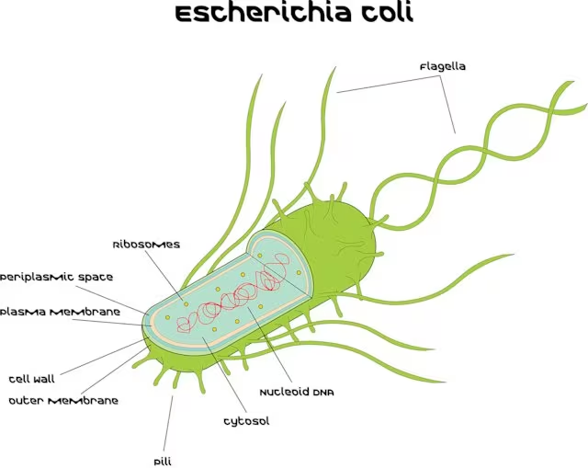

Pathogenesis
The reservoir of E. coli includes both humans and animals. The source of the E. coli that causes urinary tract infections is the patient’s own colonic flora that colonizes the urogenital area. The source of the E. coli that causes neonatal meningitis is the mother’s birth canal; the infection is acquired during birth. In contrast, the E. coli that causes traveler’s diarrhea is acquired by ingestion of food or water contaminated with human feces. Note that the main reservoir of enterohemorrhagic E. coli O157 is cattle and the organism is acquired in undercooked beef, for example, hamburgers. Escherichia coli has several clearly identified components that contribute to its ability to cause disease: pili, a capsule, endotoxin, and three exotoxins (enterotoxins), two that cause watery diarrhea and one that causes bloody diarrhea and hemolytic–uremic syndrome.
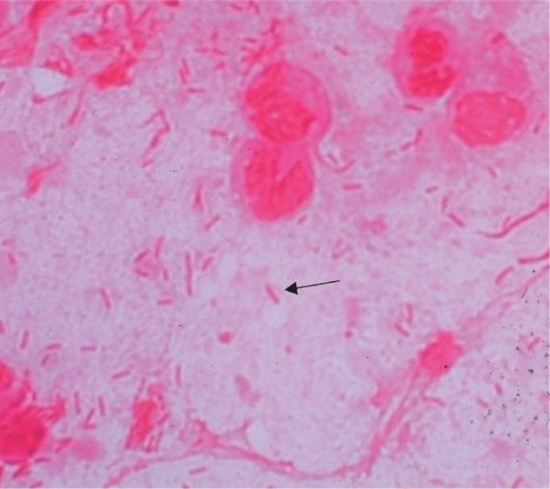
Escherichia coli—Gram stain. Arrow points to a gram-negative rod.
Intestinal Tract Infection
The first step is the adherence of the organism to the cells of the jejunum and ileum by means of pill that protrude from the bacterial surface, Once attached, the bacteria synthesize enterotoxins exotoxins that act in the enteric tract), which act on the cells of the jejunum and ileum to cause diarrhea. The toxins are strikingly cell-specific: the cells of the colon are not susceptible, probably because they lack receptors for the toxin. Enterotoxigenic strains of E. coll (ETEC) can produce either or both of two
(1) The heat-labile toxin (LT) acts by stimulating adenvlate cyclase. Both Li and cholera toxin act by catalyzing the addition of adenosine diphosphate-ribose a process called ADP-ribosylation to the G protein that stimulates the cyclase. This irreversibly activates the cyclase. The resultant increase in intracellular cyclic adenosine mono-phosphate (AMP) concentration stimulates cyclic AMP-dependent protein kinase, which phosphorylates ion transporters in the membrane. The transporters export ions, which cause an outpouring of fluid, potassium, and chloride from the enterocvtes into the lumen of the gut. resulting in watery diarrhea. Note that cholera toxin has the same mode of action.
(2) The other enterotoxin is a low-molecular-weight. heat-stable toxin (ST), which stimulates guanylate cyclase.
The enterotoxin-producing strains do not cause inflammation. do not invade the intestinal mucosa, and cause a watery, nonbloody diarrhea. However, certain strains of E coli are enteropathic (enteroinvasive) and cause disease not by enterotoxin formation but by invasion of the epithelium of the large intestine, causing bloody diarrhea (dysentery) accompanied by inflammatory cells (neutrophils) in the stool.
Some patients with bloody diarrhea caused by 0157:7 strains also have a life-threatening complication called hemolvtic-uremic syndrome (HUS) which occurs when shiga toxin enters the bloodstream. This syndrome consists of hemolytic anemia, thromboctopenia, and acute renal failure. The hemovtic anemia and rena failure occur because there are receptors for Shiga toxin on the surface of the endothelium of small blood vessels and on the surface of kidney epithelium. Death of the endothelial cells of small blood vessels results in a microangiopathic hemolytic anemia in which the red cells passing through the damaged area become grossly distorted schistocvtes and then lyse.

Systemic Infection
The other two structural components, the capsule and the endotoxin, play a more prominent role in the patnogenesis of systemic, rather than intestinal tract, disease. The capsular polysaccharide interferes with phagocytosis, thereby enhancing the organism's ability to cause infections in various organs. For example, E. coli strains that cause neonatal meningitis usually have a specitic capsular type called the K1 antigen. The endotoxin of E. coli is the cell wall lipo-polysaccharide, , which causes several features of gram-negative sepsis such as lever, hypotension, and disseminated intravascular coagulation

Clinical findings
(1) Clinical findings within the intestinal tract: Diarrhea caused ov enterotoxigenic d. con STEG IS usually waterv, nonbloodv, selfolimited, and of short dura tion -3 davs).it is trequently associated with travel trav. eler's diarrhea. or "turists"). Infection with enterohemorrhagic E. coli (EHEC), on the other hand, results in a dysentery-like syndrome characterized by bloody diarrhea, abdominal cramping, and fever similar to that caused by Shigella. The 0157:H7 strains of E. coli (STEC) also cause bloody diarrhea, which can be complicated by HUS. This syndrome is characterized by kidney failure, hemolvtic ane. mia, and thrombocytopenia. The hemolytic anemia is caused by exotoxin-induced capillary damage, which results in damage to the red cells as they pass through the capillaries. These distorted, fragmented red cells called schistocvtes can be seen on blood smear and are character. istic ot a microangiopathic hemolytic anemia. (2) Clinical findings outside of the intestinal tract:
Escherichia coli is the leading cause of community. acquired urinary tract infections. These intections occur primarily in women; this rinding is attributed to three teatures that tacilitate ascending intection into the blad der. namelv, a short urethra. the proximity of the urethra to the anus, and colonization of the vagina by members of the fecal flora. It is also the most frequent cause of nosocomial (hospital-acquired) urinary tract infections, which occur equally frequently in both men and women and are associated with the use of indwelling urinary catheters. Urinary tract infections can be limited to the bladder or extend up the collecting system to the kidneys. If only the bladder is involved, the disease is called cystitis, whereas intection of the kidney is called pyelonephritis. The most prominent svmptoms of cystitis are pain dysuria and frequency of urination: patients are usualv afebrile velonephritis is characterized by fever. flank pain. and costovertebral angle tenderness; dysuria and frequency
Escherichia coli is also a major cause, along with the group B streptococci, of meningitis and sepsis in neonates.

Laboratory Diagnosis
Specimens suspected of containing enteric gram-negative rods, such as E. coli, are grown initially on a blood agar plate and on a differential medium, such as EMB agar or MacConkey's agar. Escherichia coli, which ferments lactose, forms pink colonies, whereas lactose-negative organisms are colorless. On EMB agar, E. con colonies have a characteristic green sheen. Some of the important features that help distinguish E. coli from other lactose fermenting gram-negative rods are as follows: (1) it pro duces indole from tryptophan, (2) it decarboxylates lysine. (3) it uses acetate as its only source of carbon. And (4) it is motile. Escherichia coli 0157:H7 does not ferment sorbitol, which serves as an important criterion that distinguishes it from other strains of E. coli. The isolation or enterotoxigemic or emeropanogenic c. com trom patients with diarrhea is not a routine diagnostic procedure

Treatment
Treatment of E. coli infections depends on the site of disease and the resistance pattern of the specitic isolate. For example, an uncomplicated lower urinary tract infection (cystitis) can be treated using oral trimethoprim sulfamethoxazole or nitrofurantoin. Pvelonenhritis can be treated with ciprofloxacin or ceftriaxone. However,E.Coli sepsis requires treatment with parenteral antibiotics e.g., a third-generation cephalosporin. such as cefotaxime with or without an aminoglycoside, such as gentamicin). For the treatment of neonatal meningitis, a combination of ampicillin and cefotaxime is usually given. Antibiotic therapy is usually nor indicated in E. coli diarrheal diseases. However, administration of trimethoprim-sulfamethoxazole or loperamide Imodium may shorten the duration of symp toms. Rehydration is typically all that is necessary in this self-limited disease.

Prevention
There is no specific prevention for E. coli infections, such as active or passive immunization. However, various general measures can be taken to prevent certain intections caused by E. coli and other organisms. For example, the incidence of urinary tract infections can be lowered by the judicious use and prompt withdrawal of catheters and. in recurrent infections, by prolonged prophylaxis with urinary antiseptc drugs.
Some cases of sepsis can be prevented by prompt removal ot or switching the site of intravenous lines. Travelers diar rhea can sometimes be prevented by the prophylactic use of doxycycline, ciprofloxacin, trimethoprim-sultamethoxazole, or Pepto-Bismol. Ingestion of uncooked foods and unpurified water should be avolded waile travelne in certain countries.

SHIGELLA
Shigella species cause enterocolitis, Enterocolitis caused by Shigella is otten called bacillary dysentery. The term dysentery reters to blood diarrhea.

Important Properties
Shigellae are non-lactose-termenting, gram-negative rods that can be distinguished from salmonellae by three crite. ria: they produce no gas from the fermentation of glucose they do not produce H.S, and they are nonmotile. All shigelhe have • antigens Dolysaccharide in their cell walls, and these antigens are used to divide the genus into four groups: A, B, C, and D.

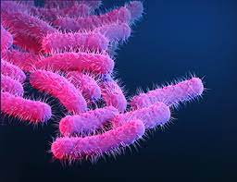
Pathogenesis & Epidemiology
Shigellae are the most eftective pathogens among the enteric bacteria. Shigellosis is only a human disease (i.e., there is no animal reservoir. The organism is transmitted by the fecal-oral route. The four Fs-fingers, flies, food, and feces- are the principal factors in transmission. Foodborne outbreaks outnumber waterborne outbreaks by 2 to 1. Outbreaks occur in day care nurseries and in mental hospitals, where recal-ora transmission is likelv to occur. Children younger than 10 years account for approximately half of Shigella-positive stool cultures. Shigellae, which cause disease almost exclusively in the gastrointestinal tract, produce bloody diarrhea (dysentery) by invading the cells of the mucosa of the distal ileum and colon. Local infiammation accompanied by ulceration occurs, but the organisms rarely penetrate through the wall or enter the bloodstream, unlike salmonellae.
Althougn some strains produce an enterotoxin called Shiga toxin), invasion is the critical factor in pathogenesis. The evidence for this is that mutants that fail to produce
enterotoxin but are invasive can stil cause disease. whereas noninvasive mutants are nonpathogenic. Shiga toxins are encoded by lysogenic bacteriophages.

Clinical Findings
Alter an incubation period of I to 4 days, symptoms begin with lever and abdomina cramps. tollowed by diarrhea. which may be watery at first but later contains blood and mucus. The disease varies from mild to severe depending on two major factors: the species of Shigella and the age of the patient, with young children and elderly people being the most severely affected. The diarrhea frequently resolves in 2 or 3 days; in severe cases, antibiotics can shorten the course. Serum agglutinins appear atter recovery bus are not protecave because the organism does not enter the blood.

Laboratory Diagnosis
Shigellae form non-lactose-termenting (colorless) colonies on MacConkeys or EMB agar. On TSI agar, they cause an alkaline slant and an acid butt, with no gas and no H2S Confirmation of the organism as Shigella and determina tion of its group are done by slide agglutination.
One important adjunct to laboratory diagnosis is a methylene blue stain of a fecal sample to determine whether neutrophils are present. If they are found, an invasive organism such as Sigella. Salmonella. or Campylobacter is involved rather than a toxin-producing organism such as V. cholerae, E. coli, or Clostridium perfringens.

Treatment
The main treatment for shigellosis is fluid and electrolyte replacement. In mild cases, no antibiotics are indicated. In severe cases, a fluoroquinolone (e.g., ciprofloxacin) is the drug of choice, but the incidence of plasmids conveying multiple drug resistance is high enough that antibiotic sensitivity tests must be performed. Trimethoprim-sulfamethoxazole is an alternative choice. Antiperistaltic drugs are contraindicated in shigellosis, because they prolong the fever, diarrhea, and excretion of the organism.

Prevention
Prevention of shigellosis is dependent on interruption of fecal-oral transmission by proper sewage disposal, chlorination of water, and personal hygiene (handwashing by food handlers). There is no vaccine, and prophylactic antibiotics are not recommended.

SALMONELLA

Diseases
Salmonella species cause enterocolitis. enteric fevers such as typhoid fever, and septicemia with metastatic infections such as osteomyents.

Important Properties
Salmonellae are gram-negative rods that do not ferment actose but do produce H2S--features that are used in their laboratory identitication. Their antigens cell wall O, fla-gellar H, and capsular Vi (virulence)-are important for taxonomic and epidemiologic purposes.

Pathogenesis & Epidemiology
The three types of Salmonella infections (enterocolitis, enteric fevers, and septicemia) have different pathogenic features.
(1 Enterocollitis is characterized by an invasion of the epithelial and subepithelial tissue of the small and large intestines Strains that do not invade do not canse disease
The organisms penetrate both through and between the mucosal cells into the lamina propria, with resulting inflammation and diarrhea. Neutrophils limit the infection to the gut and the adjacent mesenteric lymph nodes; bacte. remia is infrequent in enterocolitis, In contrast to Sinigella enterocoltis. in which the infectious dose is very small Con the order of 100 organisms), the dose of Salmonella required is much higher, at least 100,000 organisms. Various properties of salmonellae and shigellae are compared in able 8-9, Gastric acid is an important host detense; gastrectomy or use of antacids lowers the intec tious dose significantly.
(2) In typhoid and other enteric fevers, infection begins in the small intestine, but few gastrointestinal symptoms occur. The organisms enter, multiply in the mononuclear phagocytes of Peyer's patches, and then spread to the phagocytes of the liver, gallbladder, and spleen. This leads to bacteremia, which is associated with the onset of fever and other symptoms, probably caused
by endotoxin. survival and growth or the organism within phagosomes in phagocytic cells are a striking tea-ture of this disease, as is the predilection for invasion of the gallbladder, which can result in establishment of the carrier state and excretion of the bacteria in the feces for long periods.
(3) Septicemia accounts for only about 5% to 10% of
alonella infections and occurs in one or two settings; a patient with an underlying chronic disease, such as sickle cell anemia or cancer. or a child with enterocolitis. The septic course is more indolent than that seen with many other gram-negative rods. Bacteremia results in the seeding of many organs, with osteomyelitis, pneumonia, and meningitis as the most common sequelae. Osteomyelitis in a child with sickle cell anemia is an important example of this type ot salmonella infection. Previously damaged tissues, such as infarcts and aneurvsms, especially aortic
are the most frequent sites of metastatic abscesses. Salmonella are also an important cause of vascular gratt infections.
The epidemiology of Salmonella infections is related to the ingestion of food and water contaminated by human and animal wastes. Salmonella typhi, the cause of typhoid fever, is transmitted only by humans, but all other species have a significant animal as well as human reservoir.
Human sources are either persons who temporarily excrete the organism during or shortly atter an attack of enterocolitis or chronic carriers who excrete the organism for vears. The most frequent animal source is poultry and eggs, but meat products that are inadequately cooked have been implicated as well. Dogs and other pets, including turtles, snakes, lizards, and iguanas, are additional sources.

Clinical Findings
Arter an incubation period of 12 to 48 hours, enterocolitis begins with nausea and vomiting and then progresses to abdominal pain and diarrhea, which can vary from mild to severe with or without blood. sally the disease lasts a lew days, is selt-limited, causes nonbloody diarrhea, and does not require medical care except in the very voung and very old. In typhoid fever, caused by S. typhi, and in enteric fever, caused by organisms such as S. paratyphi A, B, and C (S. paratyphi B and C are also known as Salmonella schott-muelleri and Salmonella hirschfeldi, respectively), the onset of illness is slow, with lever and constipation rather than vomiting and diarrhea predominating. Diarrhea may occur early but usually disappears by the time the fever and bac teremia occur. After the first week. as the bacteremia becomes sustained, high fever, delirium, tender abdomen, and enlarged spleen occur. Rose spots (i.e., rose-colored macules on the abdomen) are associated with typhoid fever but occur only rarely. Leukopenia and anemia are often seen. Liver function tests are often abnormal, indicating hepatic involvement.
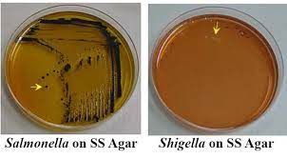
Laboratory Diagnosis
In enterocolitis, the organism is most easilv isolated from a stool sample. However, in the enteric fevers, a blood culture is the procedure most likely to reveal the organism during the first 2 weeks of illness. Bone marrow cultures are often positive. Stool cultures may also be positive, especially in chronic carriers in whom the organism is secreted in the bile into the intestinal tract. Salmonellae form non-lactose-termenting (colorless) colonies on MacConkeys or EMB agar. On ISI agar, an alkaline slant and an acid butt, frequently with both gas and H2S (black color in the butt), are produced. S. typhi is the major exception; it does not form gas and produces only a small amount of Hs. If the organism is urease-negative (Proteus organisms, which can produce a similar reaction on TSI agar, are urease-positive), the Salmonella isolate can be identified and grouped by the slide agglutination test into serogroup A, B, C, D, or E based on its O antigen Definitive serotyping of the O, H, and Vi antigens is performed by special public health laboratories for epidemio-logic purposes. Salmonellosis is a notifiable disease, and an investigaton to determine its source should be undertaken. In cer tain cases of enteric fever and sepsis, when the organism is ditticult to recover, the diagnosis can be made serologically by detecting a rise in antibody titer in the patients serum (Widal test).

Treatment
Enterocolitis caused by Salmonella is usually a self-limited disease that resolves withont treatment. Huid and electro Ite replacement may be required. Antibiotic treatment does not shorten the illness or reduce the svmptoms; in tact, it may prolong excretion ot the organisms, increase the trequency of the carrier state, and select mutants resistant to the antibiotic. Antimicrobial agents are indicated only for neonates or persons with chronic diseases who are at risk for septicemia and disseminated abscesses Plasmid mediated antibiotic resistance is common, and antibiotic sensitivity tests should be done. Drugs that retard intestinal motility (i.e., that reduce diarrhea) appear to prolong the duration or svmptoms and the recal excretion of the organisms.
The treatment of choice for enteric revers such as typhoid fever and septicemia with metastatic intection is either ceftriaxone or ciprofloxacin. Ampicillin or cipro-floxacin should be used in patients who are chronic carriers of S. typhi. Cholecystectomy may be necessary to abolish the chronic carrier state. rocal abscesses should be drained surgically when feasible.

Prevention
Salmonella infections are prevented mainly by public health and personal hygiene measures. Proper sewage treatment chlorinated water supply that is monitored for contami nation by colitorm bacteria, cultures of stool samples from food handlers to detect carriers, handwashing prior to food handling, pasteurization of milk, and proper cooking of poultry, eggs, and meat are all important. Two vaccines are available, but they confer limited (50% -80% protection against S. typhi. One contains the Vi capsular Do vsaccharide of S. tvon (given intramuscularly). and the other contains a live, attenuated strain (Ty21 a) of S typhi (given orally). The two vaccines are equally effective.

VIBRIO
Diseases
Vibrio cholera, the major pathogen in this genus, is the cause of cholera. Vibrio parahaemolyticus causes diarrhea associated with eating raw or improperly cooked seafood.
Vibrio vulnificus causes cellulitis and sepsis.

Important Properties
Vibrios are curved, comma-shaped, gram-negative rods . V. cholerae is divided into two groups according to the nature of its O cell wall antigen. Members of the 01 group cause epidemic disease, whereas non-01 organisms either cause sporadic disease or are nonpatho-gens.

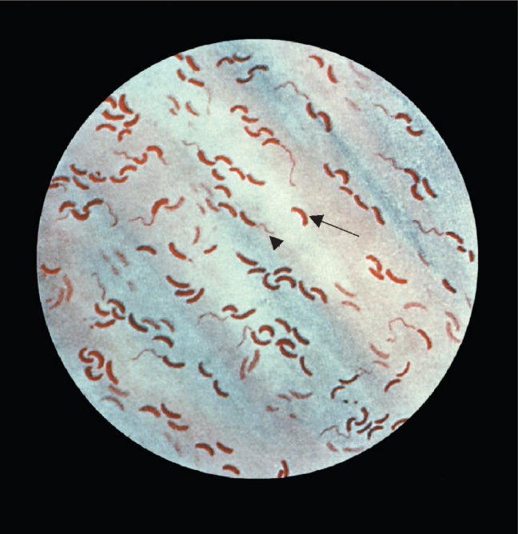
Vibrio cholerae—Gram stain. Long arrow points to a curved gram-negative rod. Arrowhead points to a flagellum at one end of a curved gram-negative rod.

1. Vibrio cholerae
Pathogenesis & Epidemiology
Vibrio cholerae is transmitted by fecal contamination of water and food, primarily from human sources. Human carriers are frequently asymptomatic and include individuals who are either in the incubation period or convalescing. The main animal reservoirs are marine shellfish, such as shrimp and oysters. Ingestion of these without adequate cooking can transmit the disease.
The pathogenesis of cholera is dependent on colonization of the small intestine by the organism and secretion of enterotoxin. For colonization to occur, large numbers of bacteria must be ingested because the organism is particularly sensitive to stomach acid. Persons with little or no stomach acid, such as those taking antacids or those who have had gastrectomy, are much more susceptible. Adherence to the cells of the brush border of the gut, which is a requirement for colonization, is related to secretion of the bacterial enzyme mucinase, which dissolves the protective glycoprotein coating over the intestinal cells. After adhering, the organism multiplies and secretes an enterotoxin called choleragen (cholera toxin). This exotoxin can reproduce the symptoms of cholera even in the absence of the Vibrio organisms.
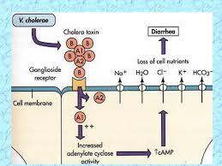

Clinical Findings
Watery diarrhea in large volumes is the hallmark of chol-era. There are no red blood cells or white blood cells in the stool. Rice-water stool is the term often applied to the nonbloody effluent. There is no abdominal pain, and subsequent symptoms are referable to the marked dehydration.
The loss of fluid and electrolytes leads to cardiac and renal failure. Acidosis and hypokalemia also occur as a result of loss of bicarbonate and potassium in the stool. The mortality rate without treatment is 40%.
Laboratory Diagnosis
The approach to laboratory diagnosis depends on the situ-ation. During an epidemic, a clinical judgment is made and there is little need for the laboratory. In an area where the disease is endemic or for the detection of carriers, a variety of selective media that are not in common use in the United States are used in the laboratory. For diagnosis of sporadic cases in this country, a culture of the diarrhea stool containing V. cholerae will show colorless colonies on MacConkey's agar because lactose is fermented slowly. The organism is oxidase-positive, which distinguishes it from members of the Enterobacteriaceae. On TSI agar, an acid slant and an acid butt without gas or HaS are seen because the organism ferments sucrose. A presumptive diagnosis of V. cholera can be confirmed by agglutination of the organism by polyvalent 01 or non-01 antiserum. A retrospective diagnosis can be made serologi-cally by detecting a rise in antibody titer in acute- and convalescent-phase sera.

Treatment
Treatment consists of prompt, adequate replacement of water and electrolytes, either orally or intravenously. Glucose is added to the solution to enhance the uptake of water and electrolytes. Antibiotics such as tetracycline are not necessary, but they do shorten the duration of symptoms and reduce the time of excretion of the organisms.

Prevention
Prevention is achieved mainly by public health measures that ensure a clean water and food supply. There are two oral vaccines. One, called Dukoral, contains killed whole cells of the O-1 strain plus recombinant cholera toxin subunit B. Antibodies induced by the vaccine prevent ingested
V. cholerae from attaching to the intestinal mucosa and neutralize any cholera toxin that is produced. The second vaccine is a killed whole cell vaccine called Shanchol. The injectable killed vaccine is no longer in use. The use of tetracycline for prevention is effective in close contacts but does not prevent the spread of a major epidemic. Prompt detection of carriers is important in limiting outbreaks.

Vibrio parahaemolyticus is a marine organism transmitted by ingestion of raw or undercooked seafood, especially shellfish such as oysters. The clinical picture caused by V. parahaemolyticus varies from mild to quite severe watery diarrhea, nausea and vomiting, abdominal cramps, and fever. The illness is selflimited,lasting about 3 days.
Vibrio vulnificus is also a marine organism (i.e., it is found in warm salt waters such as the Caribbean Sea). It causes severe skin and soft tissue infections (cellulitis), especially in shellfish handlers, who often sustain skin wounds. It can also cause a rapidly fatal septicemia in immunocompromised people who have eaten raw shellfish containing the organism.

CAMPYLOBACTER
Diseases
Campylobacter jejuni is a frequent cause of enterocolitis, especially in children. C. jejuni infection is a common antecedent to Guillain-Barré syndrome. Other Campylobacter species are rare causes of systemic infection, particularly bacteremia.
Important Properties
Campylobacters are curved, gram-negative rods that appear either comma- or S-shaped. They are microaerophilic, growing best in 5% oxygen rather than in the 20% present in the atmosphere. C. jejuni grows well at 42°C, whereas Campylobacter intestinalis4 does not—an observation that is useful in microbiologic diagnosis.
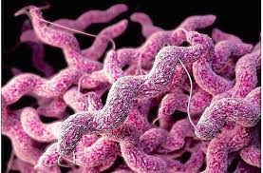
Pathogenesis & Epidemiology
Domestic animals such as cattle, chickens, and dogs serve as a source of the organisms for humans. Transmission is usually fecal–oral. Food and water contaminated with animal feces are the major sources of human infection. Foods, such as poultry, meat, and unpasteurized milk, are commonly involved. Puppies with diarrhea are a common source for children. Human-to-human transmission occurs but is less frequent than animal-to-human transmission. Campylobacter jejuni is a major cause of diarrhea in the United States; it was recovered in 4.6% of patients with diarrhea, compared with 2.3% and 1% for Salmonella and Shigella, respectively. Campylobacter jejuni is the leading cause of diarrhea associated with consumption of unpasteurized milk.
Clinical Findings
Enterocolitis, caused primarily by C. jejuni, begins as watery, foul-smelling diarrhea followed by bloody stools accompanied by fever and severe abdominal pain. Systemic infections, most commonly bacteremia, are caused more often by C. intestinalis. The symptoms of bacteremia (e.g., fever and malaise) are associated with no specific physical findings. Gastrointestinal infection with C. jejuni is associated with Guillain-Barré syndrome, the most common cause of acute neuromuscular paralysis. Guillain-Barré syndrome is an autoimmune disease attributed to the formation of antibodies against C. jejuni that cross-react with antigens on neurons ). Infection with Campylobacter is also associated with two other autoimmune diseases: reactive arthritis and Reiter’s syndrome.
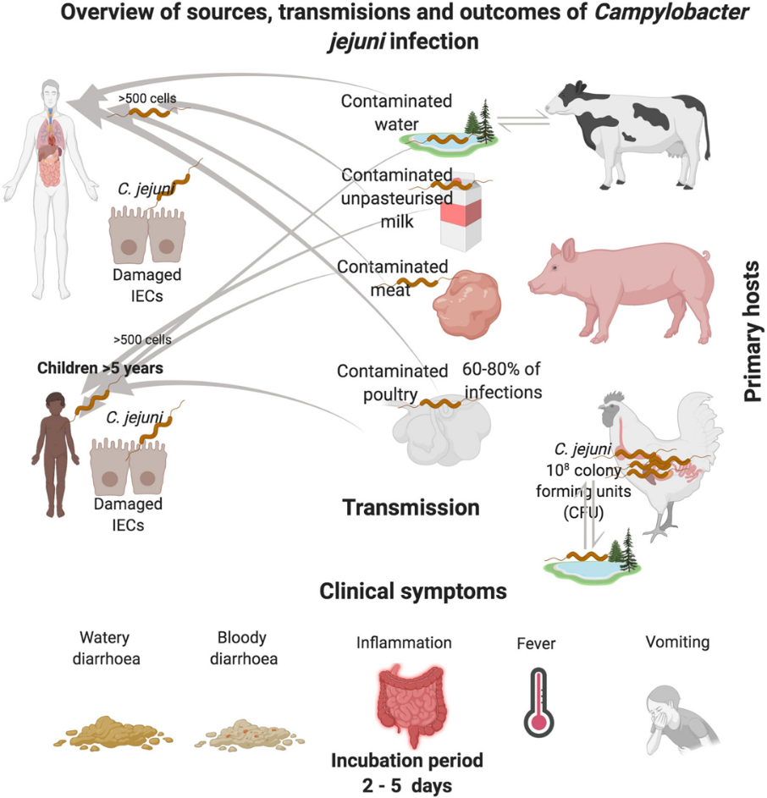
Laboratory Diagnosis
If the patient has diarrhea, a stool specimen is cultured on a blood agar plate containing antibiotics5 that inhibit most other fecal flora. The plate is incubated at 42°C in a microaerophilic atmosphere containing 5% oxygen and 10% carbon dioxide, which favors the growth of C. jejuni. It is identified by failure to grow at 25°C, oxidase positivity, and sensitivity to nalidixic acid. Unlike Shigella and Salmonella, lactose fermentation is not used as a distinguishing feature. If bacteremia is suspected, a blood culture incubated under standard temperature and atmospheric conditions will reveal the growth of the characteristically comma- or S-shaped, motile, gram-negative rods. Identification of the organism as C. intestinalis is confirmed by its failure to grow at 42°C, its ability to grow at 25°C, and its resistance to nalidixic acid.
Treatment
Erythromycin or ciprofloxacin is used successfully in C. jejuni enterocolitis. The treatment of choice for C. intestinalis bacteremia is an aminoglycoside.
Prevention
There is no vaccine or other specific preventive measure. Proper sewage disposal and personal hygiene (handwashing) are important.

HELİCOBACTER

Diseases
Helicobacter pylori causes gastritis and peptic ulcers. Infection with H. pylori is a risk factor for gastric carcinoma and is linked to mucosal-associated lymphoid tissue (MALT) lymphomas.
Important Properties
Helicobacters are curved gram-negative rods similar in appearance to campylobacters, but because they differ sufficiently in certain biochemical and flagellar characteristics, they are classified as a separate genus. In particular, helicobacters are strongly urease-positive, whereas campylobacters are urease-negative.
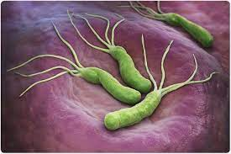
Pathogenesis & Epidemiology
Helicobacter pylori attaches to the mucus-secreting cells of the gastric mucosa. The production of large amounts of ammonia from urea by the organism’s urease, coupled with an inflammatory response, leads to damage to the mucosa. Loss of the protective mucus coating predisposes to gastritis and peptic ulcer . The ammonia also neutralizes stomach acid, allowing the organism to survive. Epidemiologically, most patients with these diseases show H. pylori in biopsy specimens of the gastric epithelium. The natural habitat of H. pylori is the human stomach, and it is probably acquired by ingestion. However, it has not been isolated from stool, food, water, or animals. Personto-person transmission probably occurs because there is clustering of infection within families. The rate of infection with H. pylori in developing countries is very high—a finding that is in accord with the high rate of gastric carcinoma in those countries. MALT lymphomas are B-cell tumors located typically in the stomach, but they occur elsewhere in the gastrointestinal tract as well. Helicobacter pylori is often found in the MALT lesion, and the chronic inflammation induced by the organism is thought to stimulate B-cell proliferation and eventually a B-cell lymphoma. Antibiotic treatment directed against the organism often causes the tumor to regress.
Clinical Findings
Gastritis and peptic ulcer are characterized by recurrent pain in the upper abdomen, frequently accompanied by bleeding into the gastrointestinal tract. No bacteremia or disseminated disease occurs.
Laboratory Diagnosis
The organism can be seen on Gram-stained smears of biopsy specimens of the gastric mucosa. It can be cultured on the same media as campylobacters. In contrast to C. jejuni, H. pylori is urease-positive. Urease production is the basis for a noninvasive diagnostic test called the “urea breath” test. In this test, radiolabeled urea is ingested. If the organism is present, urease will cleave the ingested urea, radiolabeled CO2 is evolved, and the radioactivity is detected in the breath. A test for Helicobacter antigen in the stool can be used for diagnosis and for confirmation that treatment has eliminated the organism. The presence of IgG antibodies in the patient’s serum can also be used as evidence of infection.
Treatment & Prevention
The concept that underlies the choice of drugs is to use antibiotics to eliminate Helicobacter plus a drug to reduce gastric acidity. A combination of two antibiotics is used because resistance, especially to metronidazole, has emerged. Treatment of duodenal ulcers with antibiotics (e.g., amoxicillin and metronidazole) and bismuth salts (Pepto-Bismol) results in a greatly decreased recurrence rate. Tetracycline can be used instead of amoxicillin. There is no vaccine or other specific preventive measure.

CLOSTRİDİUM
There are four medically important species: Clostridium tetani, Clostridium botulinum, Clostridium perfringens (which causes either gas gangrene or food poisoning), and Clostridium difficile. All clostridia are anaerobic, spore-forming, gram-positive rods.
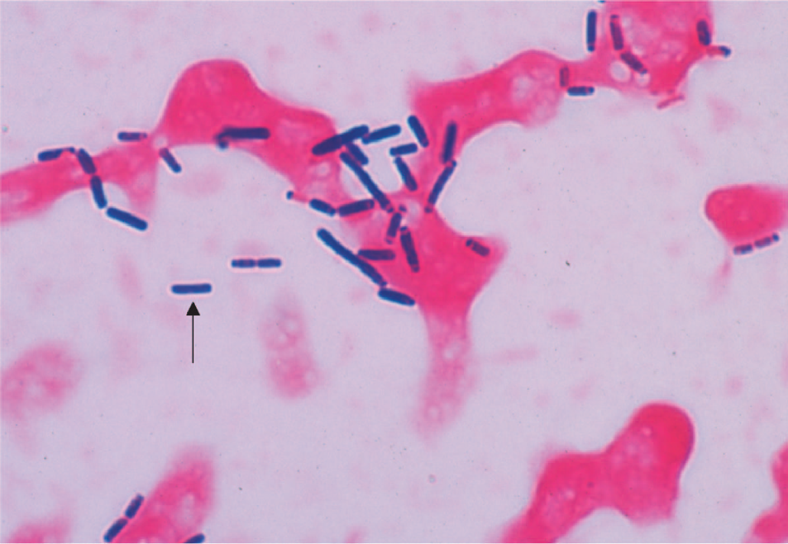
Clostridium perfringens—Gram stain. Arrow points to a large gram-positive rod.

1. Clostridium tetani
Disease
Clostridium tetani causes tetanus .
Transmission
Spores are widespread in soil. The portal of entry is usually a wound site (e.g., where a nail penetrates the foot), but the spores can also be introduced during “skin-popping,” a technique used by drug addicts to inject drugs into the skin. Germination of spores is favored by necrotic tissue and poor blood supply in the wound. Neonatal tetanus, in which the organism enters through a contaminated umbilicus or circumcision wound, is a major problem in some developing countries.
Pathogenesis
Tetanus toxin (tetanospasmin) is an exotoxin produced by vegetative cells at the wound site. This polypeptide toxin is carried intra-axonally (retrograde) to the central nervous system, where it binds to ganglioside receptors and blocks release of inhibitory mediators at spinal synapses. Tetanus toxin and botulinum toxin (see later) are among the most toxic substances known. They are both proteases that cleave the proteins involved in mediator release from the neurons. Tetanus toxin has one antigenic type, unlike botulinum toxin, which has eight. There is therefore only one antigenic type of tetanus toxoid in the vaccine against tetanus.
Clinical Findings
Tetanus is characterized by strong muscle spasms (spastic paralysis, tetany). Specific clinical features include lockjaw (trismus) due to rigid contraction of the jaw muscles, which prevents the mouth from opening; a characteristic grimace known as risus sardonicus; and exaggerated reflexes. Opisthotonos, a pronounced arching of the back due to spasm of the strong extensor muscles of the back, is often seen . Respiratory failure ensues. A high mortality rate is associated with this disease. Note that in tetanus, spastic paralysis (strong muscle contractions) occurs, whereas in botulism, flaccid paralysis (weak or absent muscle contractions) occurs.
Laboratory Diagnosis
There is no microbiologic or serologic diagnosis. Organisms are rarely isolated from the wound site. Clostridium tetani produces a terminal spore (i.e., a spore at the end of the rod). This gives the organism the characteristic appearance of a “tennis racket.”
Treatment
Tetanus immune globulin (tetanus antitoxin) is used to neutralize the toxin. The role of antibiotics is uncertain. If antibiotics are used, either metronidazole or penicillin G can be given. An adequate airway must be maintained and respiratory support given. Benzodiazepines (e.g., diazepam [Valium]) should be given to prevent spasms.

Prevention
Tetanus is prevented by immunization with tetanus toxoid (formaldehyde-treated toxin) in childhood and every 10 years thereafter. Tetanus toxoid is usually given to children in combination with diphtheria toxoid and the acellular pertussis vaccine (DTaP).
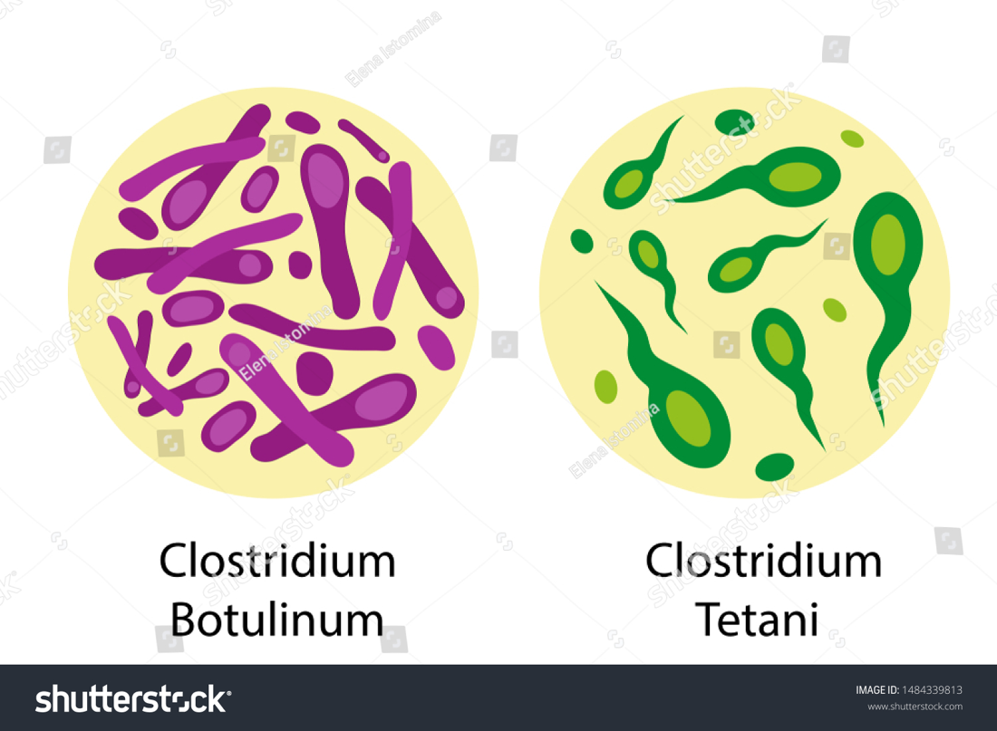

2. Clostridium botulinum
Disease
Clostridium botulinum causes botulism.
Transmission
Spores, widespread in soil, contaminate vegetables and meats. When these foods are canned or vacuum-packed without adequate sterilization, spores survive and germinate in the anaerobic environment. Toxin is produced within the canned food and ingested preformed. The highest-risk foods are (1) alkaline vegetables such as green beans, peppers, and mushrooms and (2) smoked fish. The toxin is relatively heat-labile; it is inactivated by boiling for several minutes. Thus, disease can be prevented by sufficient cooking.
Pathogenesis
Botulinum toxin is absorbed from the gut and carried via the blood to peripheral nerve synapses, where it blocks release of acetylcholine. It is a protease that cleaves the proteins involved in acetylcholine release. The toxin is a polypeptide encoded by a lysogenic phage. Along with tetanus toxin, it is among the most toxic substances known. There are eight immunologic types of toxin; types A, B, and E are the most common in human illness. Botox is a commercial preparation of exotoxin A used to remove wrinkles on the face. Minute amounts of the toxin are effective in the treatment of certain spasmodic muscle disorders such as torticollis, “writer’s cramp,” and blepharospasm.
Clinical Findings
Descending weakness and paralysis, including diplopia, dysphagia, and respiratory muscle failure, are seen. No
fever is present. In contrast, Guillain-Barré syndrome is an ascending paralysis . Two special clinical forms occur: (1) wound botulism, in which spores contaminate a wound, germinate, and produce toxin at the site; and (2) infant botulism, in which the organisms grow in the gut and produce the toxin there. Ingestion of honey containing the organism is implicated in transmission of infant botulism. Affected infants develop weakness or paralysis and may need respiratory support but usually recover spontaneously. In the United States, infant botulism accounts for about half of the cases of botulism, and wound botulism is associated with drug abuse, especially skin-popping with black tar heroin.
Laboratory Diagnosis
The organism is usually not cultured. Botulinum toxin is demonstrable in uneaten food and the patient’s
serum by mouse protection tests. Mice are inoculated with a sample of the clinical specimen and will die unless protected by antitoxin. Enzyme-linked immunoassay (EIA) tests are also used to detect the toxin and polymerase-chain reaction (PCR) tests are being developed.
Treatment
The heptavalent antitoxin containing all seven types (A to G) is preferred to the trivalent antitoxin containing types A, B, and E. Respiratory support is provided as well. The antitoxin is made in horses and serum sickness may occur. A bivalent antitoxin (types A and B) purified from the plasma of humans immunized with botulinum toxoid is available for the treatment of infant botulism.
Prevention
Proper sterilization of all canned and vacuum-packed foods is essential. Food must be adequately cooked to inactivate the toxin. Swollen cans must be discarded (clostridial proteolytic enzymes form gas, which swells cans).

3. Clostridium perfringens
Clostridium perfringens causes two distinct diseases, gas gangrene and food poisoning, depending on the route of entry into the body.
Disease: Gas Gangrene
Gas gangrene (myonecrosis, necrotizing fasciitis) is one of the two diseases caused by C. perfringens .Gas gangrene is also caused by other histotoxic clostridia such as Clostridium histolyticum, Clostridium septicum, Clostridium novyi, and Clostridium sordellii. (C. Sordellii also causes toxic shock syndrome in postpartum and postabortion women.)
Pathogenesis
Organisms grow in traumatized tissue (especially muscle) and produce a variety of toxins. The most important is alpha toxin (lecithinase), which damages cell membranes, including those of erythrocytes, resulting in hemolysis. Degradative enzymes produce gas in tissues.

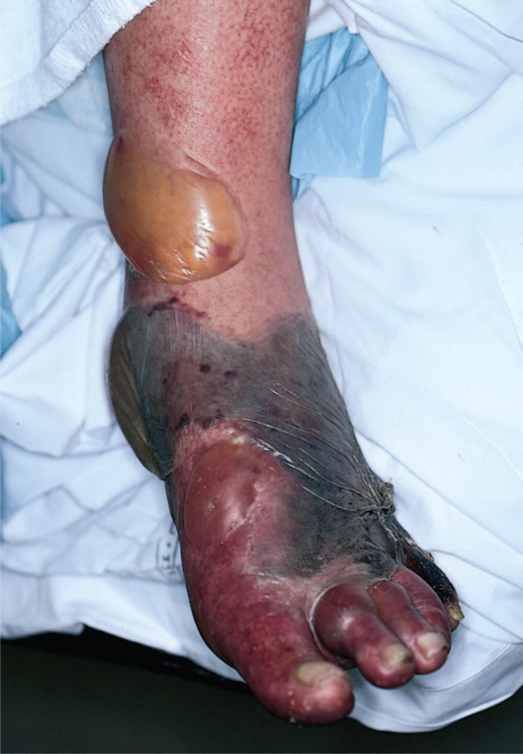
Gas gangrene. Note large area of necrosis on lateral aspect of foot. Necrosis is mainly caused by lecithinase produced by Clostridium perfringens. Gas in tissue is a feature of gangrene produced by these anaerobic bacteria. A large gas- and fluid-filled bulla is seen near the ankle.

Clinical Findings
Pain, edema, cellulitis, and gangrene (necrosis) occur in the wound area. If crepitus is palpated in the
affected tissue, it indicates gas in the tissue. This gas is typically hydrogen produced by the anaerobic bacteria. Hemolysis and jaundice are common, as are blood-tinged exudates. Shock and death can ensue. Mortality rates are high.
Laboratory Diagnosis
Smears of tissue and exudate samples show large grampositive rods. Spores are not usually seen because they are formed primarily under nutritionally deficient conditions. The organisms are cultured anaerobically and then identified by sugar fermentation reactions and organic acid production. Clostridium perfringens colonies exhibit a double zone of hemolysis on blood agar. The colonies also produce a precipitate in egg yolk agar caused by the action of its lecithinase.Serologic tests are not useful.
Treatment
Penicillin G is the antibiotic of choice. Wounds should be debrided.
Prevention
Wounds should be cleansed and debrided. Penicillin may be given for prophylaxis. There is no vaccine.

Disease: Food Poisoning
Food poisoning is the second disease caused by C. perfringens.
Transmission
Spores are located in soil and can contaminate food. The heat-resistant spores survive cooking and germinate. The organisms grow to large numbers in reheated foods, especially meat dishes.
Pathogenesis
Clostridium perfringens is a member of the normal flora in the colon but not in the small bowel, where the enterotoxin acts to cause diarrhea. The mode of action of the enterotoxin is the same as that of the enterotoxin of Staphylococcus aureus (i.e., it acts as a superantigen).
Clinical Findings
The disease has an 8- to 16-hour incubation period and is characterized by watery diarrhea with cramps and little vomiting. It resolves in 24 hours.
Laboratory Diagnosis
This is not usually done. There is no assay for the toxin. Large numbers of the organisms can be isolated from uneaten food.
Treatment
Symptomatic treatment is given; no antimicrobial drugs are administered.
Prevention
There are no specific preventive measures. Food should be adequately cooked to kill the organism.

4. Clostridium difficile
Disease
Clostridium difficile causes antibiotic-associated pseudomembranous colitis . Clostridium difficile is the most common nosocomial (hospital-acquired) cause of diarrhea. It is the leading infectious cause of gastrointestinal-associated deaths.
Transmission
The organism colonizes the large intestine of approximately 3% of the general population and up to 30% of
hospitalized patients. Note that most people are not colonized, which explains why most people who take antibiotics do not get pseudomembranous colitis. It is transmitted by the fecal–oral route. Either the spores or the bacterial organism itself can be transmitted. The majority of cases occur in hospitalized patients but
about one-third of cases are community-acquired. The hands of hospital personnel are important intermediaries.
Pathogenesis
Antibiotics suppress drug-sensitive members of the normal flora of the colon, allowing C. difficile to multiply and produce exotoxins A and B. Both exotoxin A and exotoxin B are glucosyltransferases (i.e., enzymes that glucosylate [add glucose to] a G protein called Rho GTPase). The main effect of exotoxin B in particular is to cause depolymerization of actin, resulting in a loss of cytoskeletal integrity, apoptosis, and death of the enterocytes.Clindamycin was the first antibiotic to be recognized as a cause of pseudomembranous colitis, but many antibiotics are known to cause this disease. At present, thirdgeneration cephalosporins are the most common cause because they are so frequently used. Ampicillin and fluoroquinolones are also commonly implicated. In addition to antibiotics, cancer chemotherapy also predisposes to pseudomembranous colitis. Clostridium difficile rarely invades the intestinal mucosa.
Clinical Findings
Clostridium difficile causes diarrhea associated with pseudomembranes (yellow-white plaques) on the colonic mucosa . The diarrhea is usually not bloody, and neutrophils are found in the stool in about half of the cases. Fever and abdominal pain often occur. The organism rarely enters the blood stream and rarely causes metastatic infection. The pseudomembranes are visualized by sigmoidoscopy. Toxic megacolon can occur, and surgical resection of the colon may be necessary. Pseudomembranous colitis can be distinguished from the transient diarrhea that occurs as a side effect of many oral antibiotics by testing the presence of the toxin in the stool. Even with adequate treatment, the organism may not be eradicated from the colon and recurrences occur at a rate of approximately 15% to 20%.
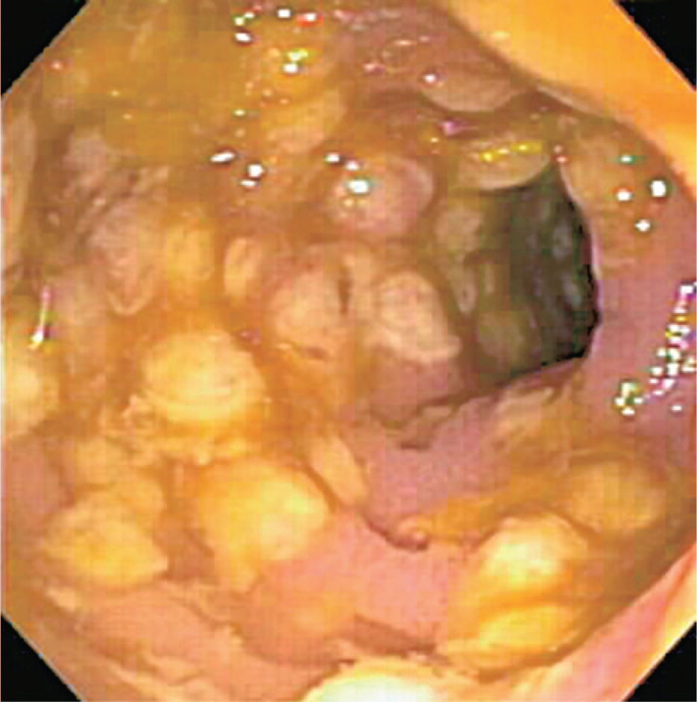
Pseudomembranous colitis. Note yellowish plaquelike lesions in colon. Caused by an exotoxin produced by Clostridium difficile that inhibits a signal transduction protein, leading to death of enterocytes

Laboratory Diagnosis
The presence of exotoxins in the filtrate of a patient’s stool specimen is the basis of the laboratory diagnosis. It is insufficient to culture the stool for the presence of C. difficile because people can be colonized by the organism and not have disease. There are two types of tests used to make the laboratory diagnosis. One detects the exotoxin itself and the other detects the genes that encode the exotoxin. To detect the exotoxin itself, an ELISA test employing antibody to the exotoxin is used. To detect the genes that encode the exotoxin, a PCR assay to determine the presence of the toxin gene DNA is used. The DNA-based test has greater sensitivity and specificity than the ELISA test.
Treatment
The causative antibiotic should be withdrawn. Oral metronidazole or vancomycin should be given and fluids replaced. Metronidazole is preferred because using vancomycin may select for vancomycin-resistant enterococci.However, in life-threatening cases, vancomycin should be used because it is more effective than metronidazole. Also in life-threatening cases, surgical removal of the colon may be required. In many patients, treatment does not eradicate the carrier state, and recurrent episodes of colitis can occur. Fidaxomicin (Dificid) is used both in the treatment of pseudomembranous colitis and in preventing relapses of this disease. It is effective in life-threatening cases. Fecal transplantation is another possible therapeutic approach. It involves administering bowel flora from a normal individual either by enema or by nasoduodenal tube to the patient with pseudomembranous colitis. This approach is based on the concept of bacterial interference (i.e., to replace the C. difficile with normal bowel flora). Very high cure rates are claimed for this technique, but aesthetic considerations have limited its acceptance.
Prevention
There are no preventive vaccines or drugs. Because antibiotics are an important predisposing factor for pseudomembranous colitis, they should be prescribed only when necessary. In the hospital, strict infection control procedures, including rigorous handwashing, are important. Probiotics, such as the yeast Saccharomyces, may be useful to prevent pseudomembranous colitis.

BACTEROIDES & PREVOTELLA
Diseases
Members of the genus Bacteroides are the most common cause of serious anaerobic infections (e.g., sepsis, peritonitis, and abscesses). Bacteroides fragilis is the most frequent pathogen. Prevotella melaninogenica is also an important pathogen. It was formerly known as Bacteroides melaninogenicus, and both names are still encountered.
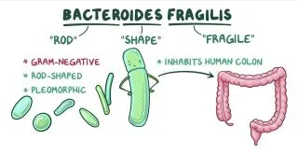
Important Properties
Bacteroides and Prevotella organisms are anaerobic, non– spore-forming, gram-negative rods. Of the many species of Bacteroides, two are human pathogens: B. fragilis7 and Bacteroides corrodens. Members of the B. fragilis group are the predominant organisms in the human colon, numbering approximately 1011/g of feces, and are found in the vagina of approximately 60% of women. Prevotella melaninogenica and B. corrodens occur primarily in the oral cavity.
Pathogenesis & Epidemiology
Because Bacteroides and Prevotella species are part of the normal flora, infections are endogenous, usually arising from a break in a mucosal surface, and are not communicable. These organisms cause a variety of infections, such as local abscesses at the site of a mucosal break, metastatic abscesses by hematogenous spread to distant organs, or lung abscesses by aspiration of oral flora. Predisposing factors such as surgery, trauma, and chronic disease play an important role in pathogenesis. Local tissue necrosis, impaired blood supply, and growth of facultative anaerobes at the site contribute to anaerobic infections. The facultative anaerobes, such as E. coli, utilize the oxygen, thereby reducing it to a level that allows the anaerobic Bacteroides and Prevotella strains to grow. As a result, many anaerobic infections contain a mixed facultative and anaerobic flora. This has important implications for therapy; both the facultative anaerobes and the anaerobes should be treated. The polysaccharide capsule of B. fragilis is an important virulence factor. The host response to the capsule plays a major role in abscess formation. Note also that the endotoxin of B. fragilis contains a variant lipid A that is missing one of the fatty acids and consequently is 1000-fold less active than the typical endotoxin of bacteria such as Neisseria meningitidis. Enzymes such as hyaluronidase, collagenase, and phospholipase are produced and contribute to tissue damage.Enterotoxin-producing strain of B. fragilis can cause diarrhea in both children and adults.
Clinical Findings
The B. fragilis group of organisms is most frequently associated with intra-abdominal infections, either peritonitis or localized abscesses. Pelvic abscesses, necrotizing fasciitis, and bacteremia occur as well. Abscesses of the mouth, pharynx, brain, and lung are more commonly caused by P. melaninogenica, a member of the normal oral flora, but B. fragilis is found in about 25% of lung abscesses. In general, B. fragilis causes disease below the diaphragm, whereas P. melaninogenica causes disease above the diaphragm. Prevotella intermedia is an important cause of gingivitis, periodontitis, and dental abscess.
Laboratory Diagnosis
Bacteroides species can be isolated anaerobically on blood agar plates containing kanamycin and vancomycin to inhibit unwanted organisms. They are identified by biochemical reactions (e.g., sugar fermentations) and by production of certain organic acids (e.g., formic, acetic, and propionic acids), which are detected by gas chromatography. Prevotella melaninogenica produces characteristic black colonies.
Treatment
Members of the B. fragilis group are resistant to penicillins, first-generation cephalosporins, and aminoglycosides, making them among the most antibiotic-resistant of the anaerobic bacteria. Penicillin resistance is the result of β-lactamase production. Metronidazole is the drug of choice, with cefoxitin, clindamycin, and chloramphenicol as alternatives. Aminoglycosides are frequently combined to treat the facultative gram-negative rods in mixed infections. The drug of choice for P. melaninogenica infectionsis either metronidazole or clindamycin. β-Lactamase–producing strains of P. melaninogenica have been isolated from patients. Surgical drainage of abscesses usually accompanies antibiotic therapy, but lung abscesses often heal without drainage.
Prevention
Prevention of Bacteroides and Prevotella infections centers on perioperative administration of a cephalosporin, frequently cefoxitin, for abdominal or pelvic surgery. There is no vaccine.

